Vishal Patel, Karandeep Chana & Matthew Strudwick

University of Brighton

Game Report

CI328 – Assessment 2, Game Design and Implementation

**Game Summary**

Overview

The game is called ‘The Hunting’. It’s a game of the action genre. It’s a network multiplayer game where each player controls a spaceship. The spaceship is able to fire laser bullets. The main aim of the game is to eliminate enemy spaceships until one spaceship remains. The player who controls that spaceship wins. We used Adobe Flash Professional and SmartFoxServer to create our game.

Objectives

* Choose a spaceship from a selection of four.
* Control the multi-directional moving spaceship using Arrow keys.
* Destroy enemy players via a firing system using Spacebar key.
* Maintain the health bar above 0.
* Survive until you’re the last player remaining.

Rules

* The player must select a spaceship before you start the game, once selected it cannot be changed until that round is over.
* The spaceship can be moved 360 degrees. However it can’t go off the bounds of the map.
* Laser bullet ammunition is unlimited, hence every player can fire an unlimited amount of laser bullets.
* A minimum of two players are required for the game to begin.
* Each round will end, either if one player is remaining having eliminated all other players, or if all players but one have left the game, thus leaving that last remaining player the winner.

Gameplay

A player is spawned in a random location on the map. They will have full health, three bars. Immediately they may or may not see enemies, they must navigate around the map looking for enemies. Once they find them, they will begin firing laser bullets to kill them. When a player is killed they’re faced with a game over screen asking them to either spectate the game or exit. Their score will also be displayed. If they spectate they will watch the remaining players. When the winning player kills the final opponent, they are faced with a game over screen as well. However they will not have a spectate button, only an exit button.

**Screen/Level Map**

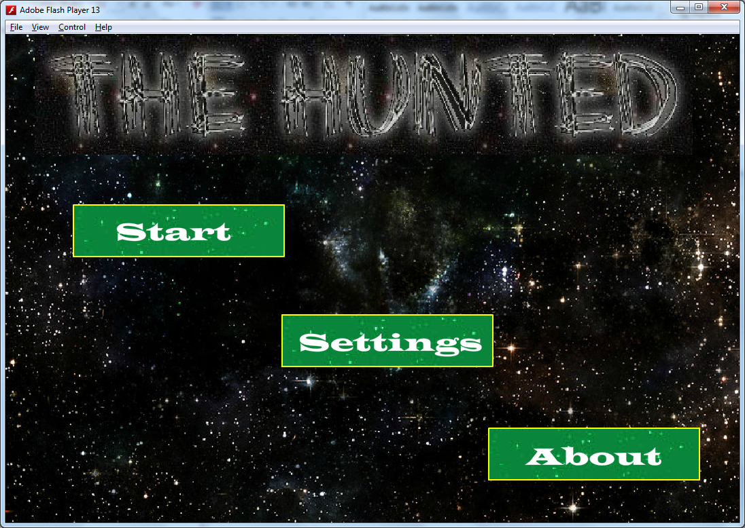

Buttons

Here is the first screen, which is shown, when the game is first started, The MenuScreen. Pressing any of the buttons directs to the respective screen.

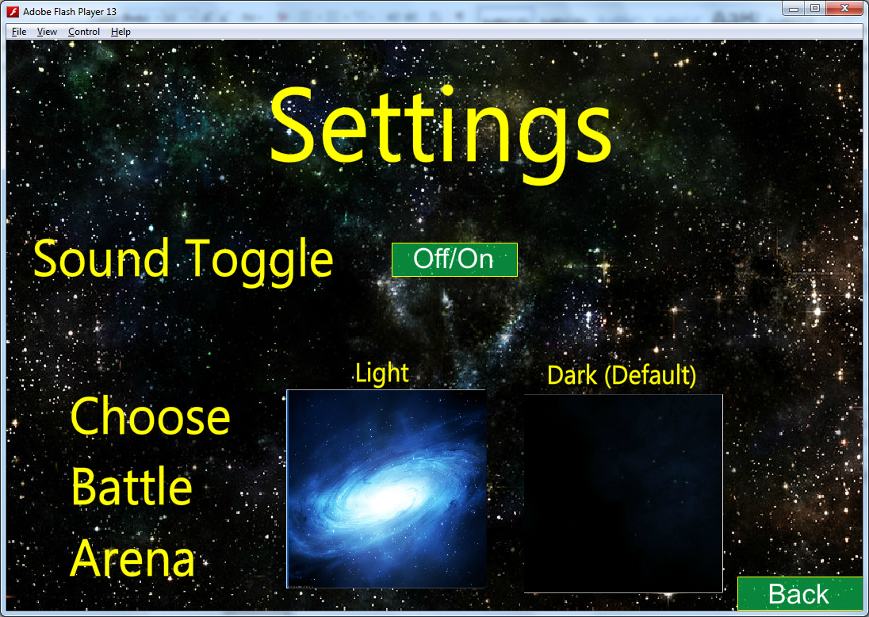

If the Settings button is pressed on the MenuScreen, the SettingsScreen is displayed. Here settings about the game can be altered. The Back button goes back to the MenuScreen.

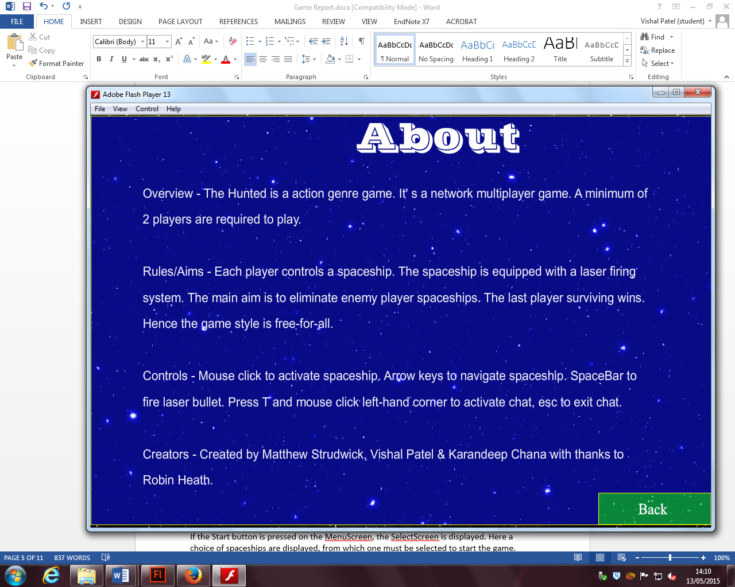

If the About button is pressed on the MenuScreen, the AboutScreen is displayed. Here information about the game is displayed. The Back button goes back to the MenuScreen.

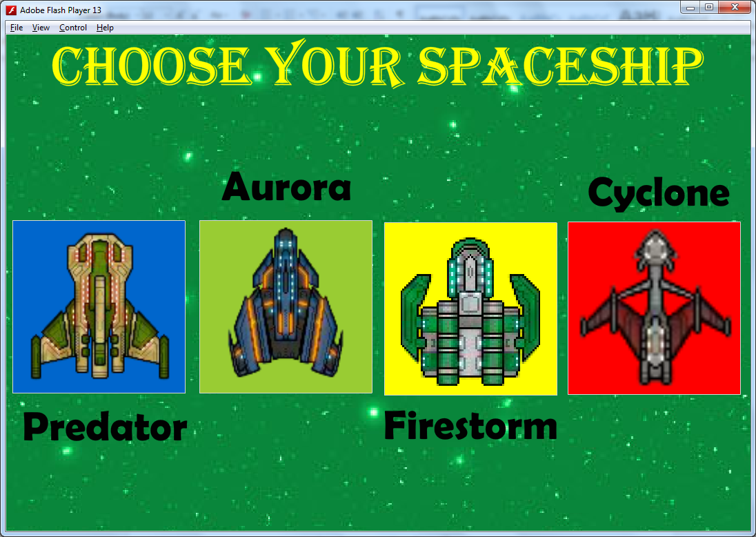

If the Start button is pressed on the MenuScreen, the SelectScreen is displayed. Here a choice of spaceships are displayed, from which one must be selected to start the game.

**Network Utilization**

Network Architecture

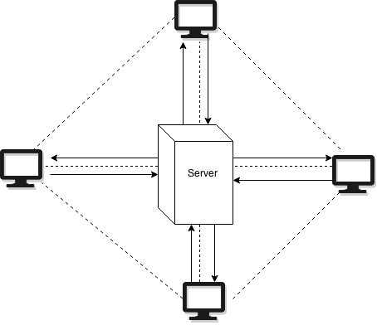

Diagram 1 - Network architecture(peer to peer)

Component Interactions

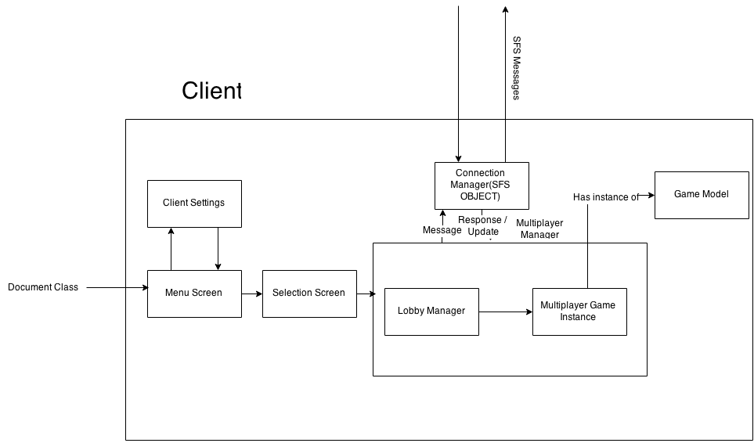

Diagram 2 - Components

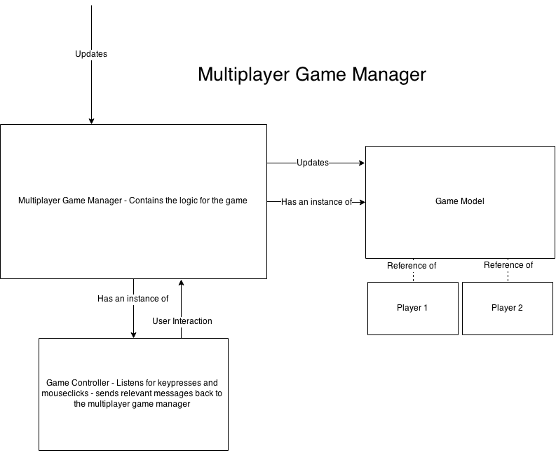

Diagram 3 - Multiplayer manager diagram

**Implementation Specification**

**Clients**

Objects

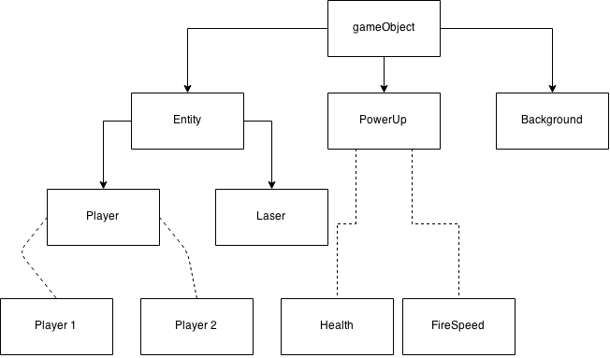

Diagram 4 - Class inheritance

Code Structure

The game has been created to be as object orientated and modular as possible from its conception. Diagram 2 shows represents the majority of the classes created for this project. A document class with the name ‘Main’ is used as the overall controller for the program acting as the selector between the screens and as a method to hold global variables for its children to use.

Once the game starts an instance of multiplayer manager is called, multiplayer manager contains everything needed in order to play a game. The game has been loosely designed to follow an MVC architecture with the multiplayer manager acting as the view with child classes Game Model and Game Controller. Diagram 3 shows how the multiplayer manager interacts with its children.

The multiplayer manager also has an instance of the connection manager which makes use of the smart fox server API in order to connect to the server an interact with the other clients.

As the game has a peer to peer infrastructure only using the server to route the messages, each client has their own game model, in order to make the game run as smoothly as possible the clients own player handles their own movement, while this does mean that there will be some difference in position due to latency between the players own representation and of others of the players ship it was decided that it would be worse to have the players own character having a delay, this was a compromise that we decided was appropriate to provide a better gameplay experience.

Within multiplayer manager a timer is used firing ever 10 milliseconds in order to send a message to the other players, every message sent contains a header such as “!up”, this was the method used of differentiating between the messages sent. In this case “!up” represents a player update and contains their x and y positions, their current rotation and their user name so that the other players known which player to update.

Similarly “!f” is used to say that a projectile has been fired sending also the x and y postions, the rotation, the player that fired the projectiles and the lasNum which is an integer representing the colour of the fired laser.

When a player joins the game they broadcast the message “!addPlayer x y username shipnum” where shipnum is an integer representing the chosen ship type. When the existing players receive this message they add the player to their own model and will respond with their own “!addPlayer” with their current location message allowing the new player to know the state of the current game.

In order to make the game as fair as possible a projectile is sent via a message even to the player that fired the projectile, while this could possibly mean that projectiles are delayed in firing, it ensures that the projectiles are mostly synchronised between players preventing a scenario where a player was hit on one screen but not on the other. The player is immune to their own projectile which is the reason that the player that sent the projectile is sent in the message.

Rather than continuously updating a projectile with messages which could cause the server to be overloaded with messages only one message per projectile is sent, when a message is received the players create an instance of the projectile within their own model.

Players will only check for collisions with themselves announcing to the rest of the players that they have been destroyed if their life runs out.

As shown by diagram 4 Inheritance is used in the game, this allowed for the user of default values and functions to be used which can be inherited, the overall class is called gameObject and all elements within the game inherit from this gameObject simply extends from movieClip. The class Entity which is a subclass of gameObject represents those gameObjects that will have to be updated and therefore contain the “update” function, these Entity’s are then stored in an array so that they can be iterated over and updated.

Examples of Entity’s are the missiles which will have to be updated every frame.

The game has been designed to be as open as possible, the play area is quite large and the players spawn in random locations, there is currently no limit on the maximum amount of players than can join a game.

Assets

**Buttons:**

SpaceButton - This is the main button which we use throughout the game. This buttons were created in Adobe Photoshop. Variants of this button were made to take different button actions e.g. rollover.



Ships – We created four different buttons to represent the four different spaceships that can be chosen for the game. The buttons were created in Adobe Flash Professional, with the images on the buttons, of the ships, coming from the internet.

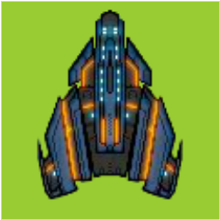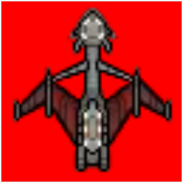 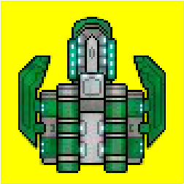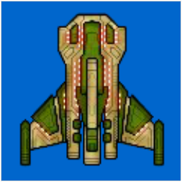

Maps – These buttons are made up of images from which are the maps used in the game. The two buttons are called light and dark respectively. The buttons were created in Adobe Flash Professional, with the images on the buttons, of the maps, coming from the internet.

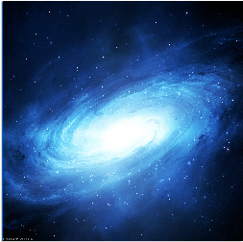

**Images:**

Spaceships – We used four images for four different spaceships. The images are from the internet.

 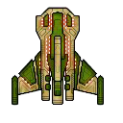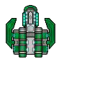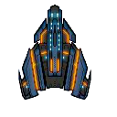

Beams – This is the main image from which we cropped four different colour images. Those four images were then used as the laser bullet objects, which the spaceship fires. The image is from the internet.

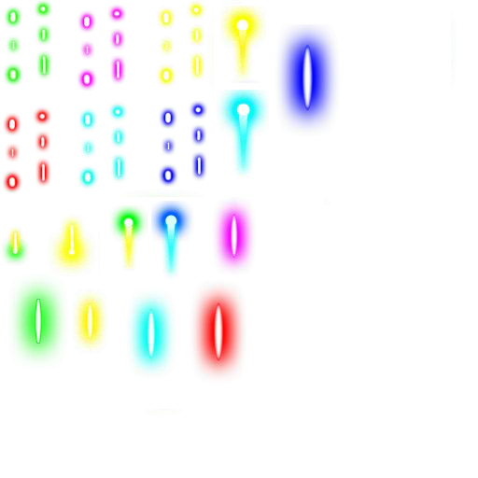

Title – This image is the title image which is used on the menu screen. The image was created using an online custom font text generator.



MenuScreen Background – This image is a space themed image which is displayed on the menu screen. The image is from the internet.

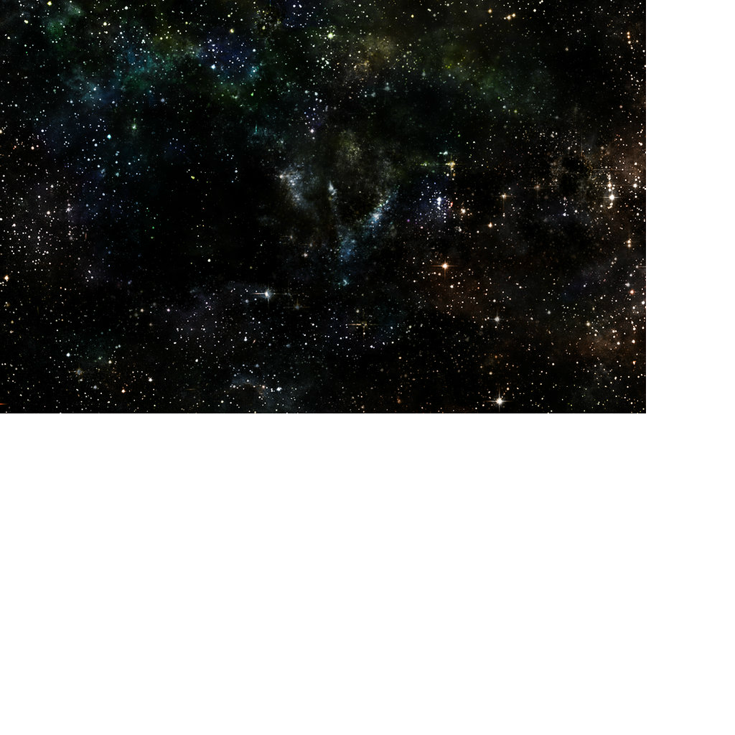

Light Map Background – This image is a blue colour space themed image which is one of the two game maps. The image is from the internet.

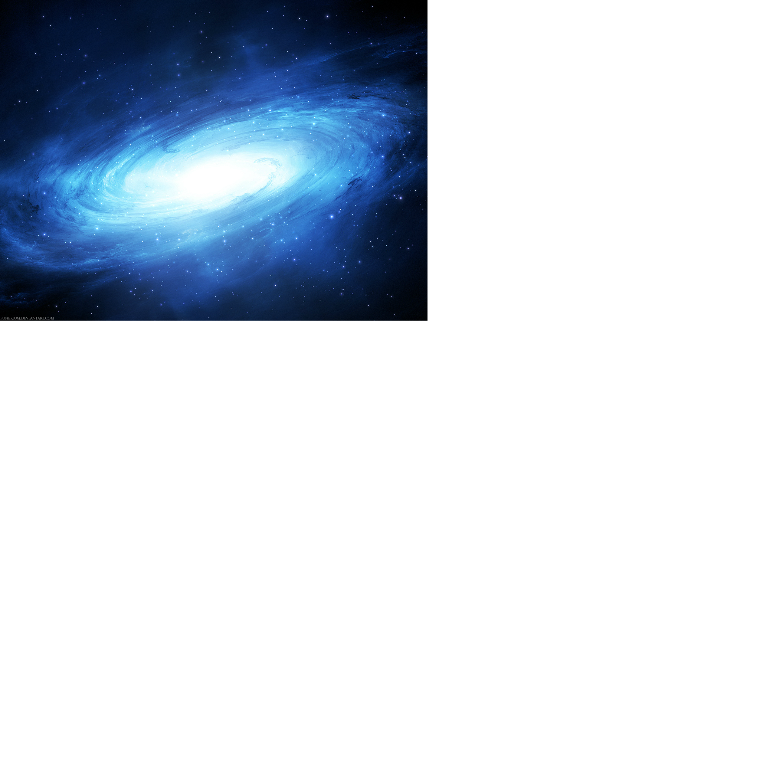

Dark Map Background – This image is a black colour space themed image which is the other of the two game maps. The image is from the internet.



Screen Backgrounds – We created two different colour images to use as the background on various movieclips. This images were created in Adobe Photoshop.

 

**Sounds:**

Theme – We created our own theme music for our game. The theme was created using Logic Pro X.

Laser Sounds – We also created laser sounds which are used throughout the game. These sounds were also created using Logic Pro X.

**Server**

Data Structures

Code Structure

**Implementation Evaluation**

Adobe Flash Professional

Strengths:

* Easy to create and manipulate interchangeable screens via movieclips.
* Easy to create simple buttons and objects.
* Good choice of fonts.
* Works with SmartFoxServer.
* Actionscript is a powerful but easy to pick up language.

Weaknesses:

* No native 3D support.
* Has limitations if advanced game development is required.

Adobe Photoshop

Strengths:

* Professional looking images can be created or edited quickly.
* An array of image manipulation tools and effects.
* Images can be saved in various formats.

Weaknesses:

* Not easy to pick up for beginners.
* Images created from it can look hugely artificial.
* It’s very expensive.

SmartFoxServer

Strengths:

* High level features, e.g. room management.
* Can support a huge number of players, 100.
* Cross platform, Mac and Windows compatible.
* It’s free.

Weaknesses:

* We didn’t find any weaknesses.

Logic Pro X

Strengths:

* Professional sounding music can be created quickly.
* A big collection of royalty free loops.
* Supports MIDI.

Weaknesses:

* Not easy to pick up for beginners.
* Only compatible on Mac machines running OSX.
* Relatively expensive.

**References**

Space-Star Background (Website) - <http://fantmayo.deviantart.com/art/Stars-Background-211786850>

Light Space Background (Website) - Reference - <http://wallpaper-kid.com/cool-space-background-blue.htm>

The Hunted Custom Font Title (Website) - <http://www.cooltext.com>

**Appendix 1:** **Game Concept Presentation**

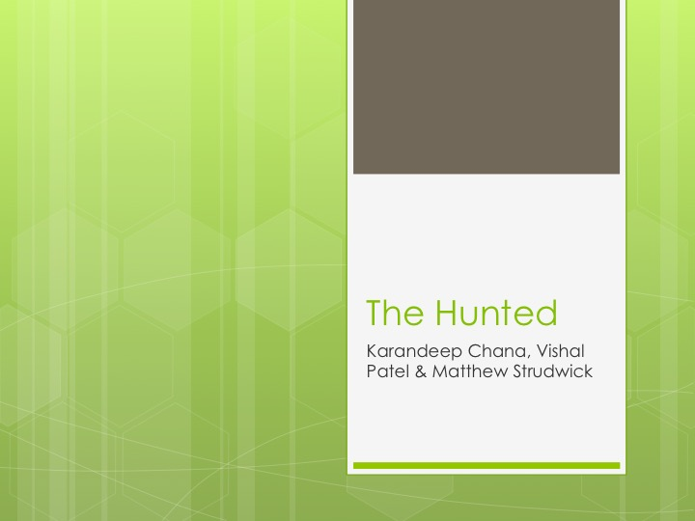

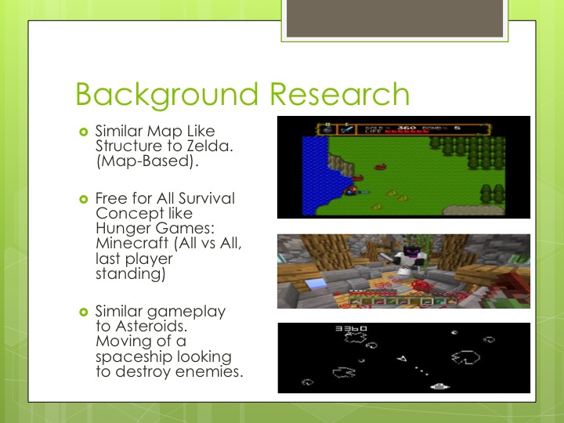

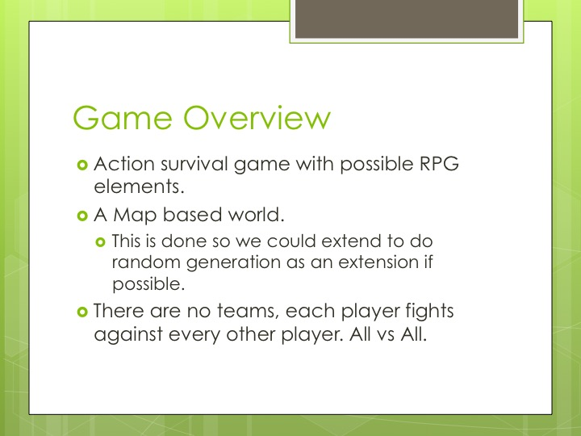

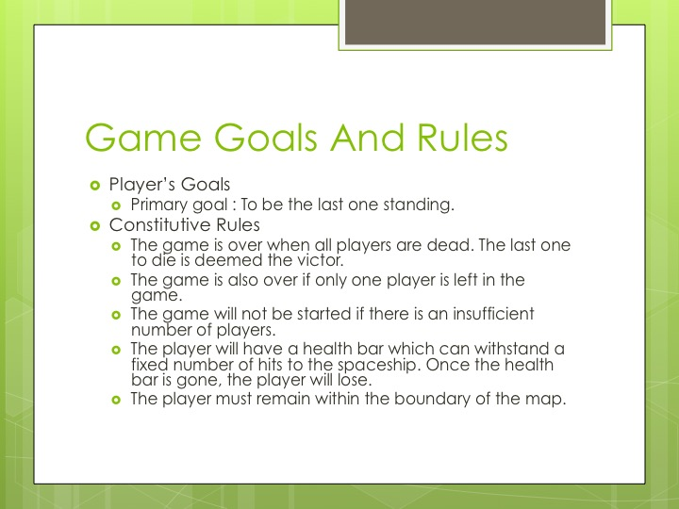

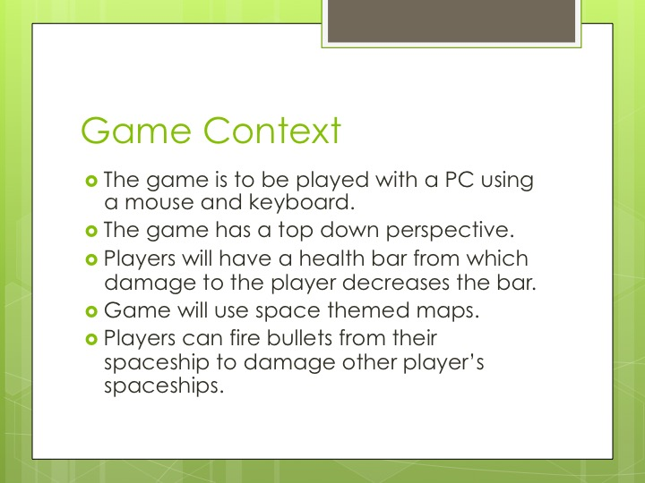

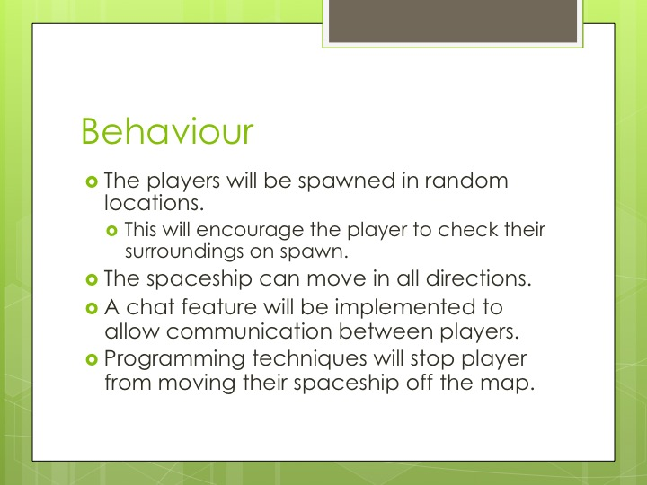

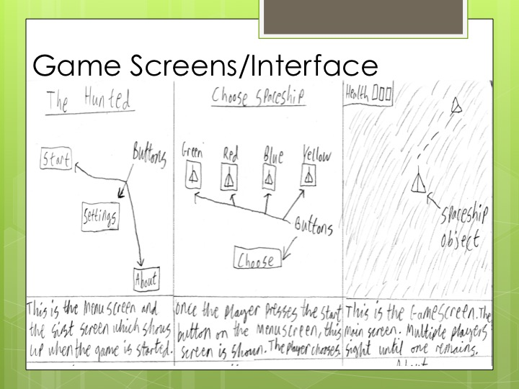

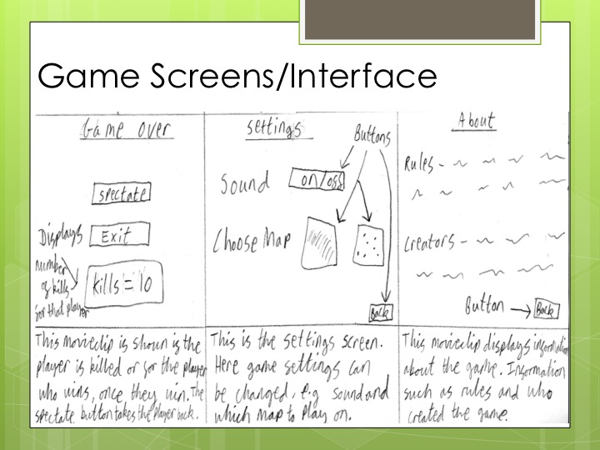



**Appendix 2:** **Extra Information**